12 Family Fun Minute to Win It Games

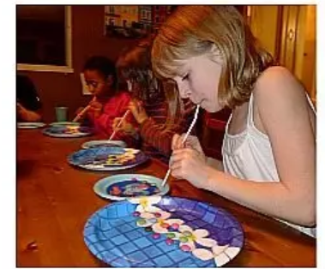 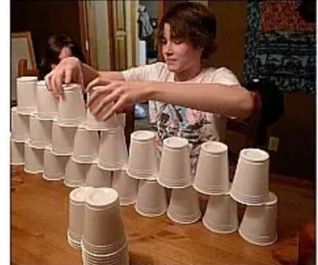 

Are you looking for a fun way to break up the day? Need to shake things up a bit? Do you just need a good laugh or a reason to smile? If so, consider playing one of the following family minute to win it games. Many of these games require minimal supplies that are probably hanging around the house! Feel free to take pictures and pass them along via email or class Dojo! I’d love to see families sharing a few laughs together!

Get your timer ready! In a minute, ( yes one minute) challenge each other to complete the following games…

**1. Keep ‘Em Up**  
Challenge yourself to keep a balloon ( or two) in the air WITHOUT using your hand! The person to do this the longest wins !

**2. Blue Moves**  
Stack 20-ish cups on top of one cup of a different color ( you can use a clear cup and just use a marker to color it) . Have players rotate through all the cups until colored cup is on top.

**3.Cookie Face**  
Place a cookie on each player’s forehead. Who can move the cookie to their mouth without using their hands first/fastest? The person who can do this first is the winner! Be prepared for some silly faces and moves!

**4. Bottle to Bottle**  
Fill one 2-Liter bottle with anything — pasta, rice, marbles, cereal, mini-marshmallows, etc. Players must try to transfer one bottle’s contents into another bottle. Whoever can transfer the most within the minute will win. Trust me: There will be spillage, so avoid liquid.

5**. Roll-On, Buddy**  
Try to roll a potato, sweet potato, onion, or any similar shaped item across the floor from one side of the room to the other.. using only your nose.

**6. Nose Mover**  
Using only your nose (and maybe a bit of peanut butter or Vaseline on the tip), how many cotton balls can you move from one bowl to the other?

**7, Look, Ma, No Fingers**  
Have players wear oven mitts and unwrap candy. Whoever can unwrap the most candy in a minute is the winner.

**8.Cotton Ball Scoop**  
Sprinkle cotton balls on a table around a centrally located bowl. Give a player a spoon and blindfold them. They have a minute to find cotton balls and put them in the bowl.

**9. Save the Joker**  
Place a stack of cards (with the joker on the bottom) atop a container. Each player has a minute to blow away the rest of the stack and leave just the joker remaining. If they lose the joker, they lose the game.

**10. Cereal Scramble**  
Cut the front of a cereal box into 14 squares. Give each player a minute to reassemble the front of their box.

**11. Tallest Tower**  
How many pennies/cereal pieces can you stack in one minute, using only one hand? Tallest tower wins. (Too easy? Make bigger kids and grown-ups use their less dominant hand.)

**12. Apple Stack**  
Allot five apples per player and give them a minute to see if they can get all five of the lumpy fruits stacked on top of each other.